Evaluation of the Effect of Relative Humidity of Air on the Coefficients of Critical Flow Venturi Nozzles

K. Chahine and M. Ballico
National Measurement Institute, Australia
P O Box 264, Lindfield, NSW 2070, Australia
Khaled.Chahine@measurement.gov.au

Abstract

At NMIA, volumetric standards such as Brooks or bell provers are used to calibrate critical flow Venturi nozzles or “sonic nozzles”. These nozzles, which are extremely stable, are used by both NMIA and Australian accredited laboratories to establish continuous flows for the calibration of gas flow meters. For operational reasons, sonic nozzles are generally calibrated using dry air but later used with standard atmospheric air at various humidity levels either drawn or blown through the meter-under-test. Although the accepted theoretical calculations for determining the mass flow through a sonic nozzle incorporate corrections for the resulting change in air density, as laboratories seek to reduce uncertainties the validity of this assumption warrants further examination. In this paper we report on the calibration of sonic nozzles from 0.1 mm to 6.5 mm ID (0.005 to 25 m³ h⁻¹) in humidified air, at atmospheric pressure and room temperature, provided by a divided flow generator over the range from dry to 95%RH air. The measured change, of up to 0.12%, somewhat larger than predicted by the theoretical calculations of other workers, is comparable with the typical calibration uncertainty for calibrations using sonic-nozzles.

Introduction
Critical flow Venturi nozzles (or sonic nozzles) generally consist of a carefully machined hole in a block of steel. The profile of this hole is carefully designed with a slowly constricting throat to accelerate the gas flow, with a shock-wave forming at the narrowest point. The mass flow is then determined, to first order, by the area of the hole and the local sound speed. As the mechanical construction is exceedingly simple, these artefacts are extremely convenient, stable and robust flow standards.

At NMIA, nozzles are generally calibrated at room temperature and over a range of pressures of a few kPa around atmospheric pressure using volumetrically calibrated reference standards such as a “Brooks” or “bell” prover, and achieving uncertainties of 0.11% and 0.13% respectively associated with the discharge coefficient [1]. To ensure the highest level of precision, nozzle calibrations are generally conducted using dry-air, with a dew/frost point less than -10°C, equating to less than 3%RH. Once calibrated, these nozzles are then used in build-up systems to calibrate other flowmeters (eg rotary and variable area). At NMIA, we presently have capacity to generate flows up to 500 m³ h⁻¹ at atmospheric pressures. To establish stable sonic conditions in the nozzle, the down-stream end of the nozzle is usually connected to a high-capacity vacuum pump, with the up-stream end connected to the meter-under-test. During calibration the test-flowmeter draws air from the laboratory at or near atmospheric pressures and temperature, and with relative humidity varying between 40% and 60%. The mass flowrate produced by the nozzles is calculated based on the calibrated values of the nozzle coefficient, the measured up-stream pressure and the density calculated from the air temperature, pressure and humidity [2].

At present, any effect of the relative humidity on the nozzle coefficients is considered as negligible, as various authors have estimated the systematic error at 0.02% for air at 50%RH, which is small compared to the typical calibration uncertainty of a rotary flowmeter of 0.15%. At NMIA we are presently establishing a new primary flow standard, based on the “PVTt” principle, aiming to significantly reduce the calibration uncertainties of sonic-nozzles, and it is expected that the effect of humidity on nozzle-coefficient will require more detailed investigation.

Theory
ISO9300 gives equations that allow the prediction of the mass flow rate from a sonic nozzle of a specified design based on a mixture of equations from fluid dynamics and a number of empirically determined functions expressed as tabulated data.

Although we are not interested in the use of ISO9300 for the prediction of the nozzle discharge coefficient it is still worthwhile to consider if it may be useful for predicting the change in nozzle coefficient with small changes in the gas composition arising from the addition of water vapour.

For a gas under real conditions, the mass flowrate q_{m} produced by a critical flow Venturi nozzle can be calculated using the sonic-nozzle equation [3],

$q_{m}=A_{nt}C_{d^{'}}C_{R}\sqrt{p_{0}ρ_{0}}$ (1)

where $A_{nt}={πd^{2}}/4$ is the cross-section area of the Venturi nozzle throat of diameter d, $C_{d^{'}}$ is the coefficient of discharge, $C_{R}$ is the critical flow coefficient for one-dimensional flow of a real gas, $p_{0}$ is the absolute stagnation pressure of the gas at nozzle inlet, and $ρ_{0}$ is the gas density at stagnation conditions at nozzle inlet.
ISO9300 provides tabulated values of these two coefficients for nozzles of a tightly specified design, allowing these nozzles to generate known flows based purely on dimensional measurements of the nozzle throat with uncertainties (estimated in ISO9300) varying from 0.13% to 0.30%. However the precision dimensional characterisation required can be difficult, especially for small nozzles, and experimental determination of the effective nozzle coefficient N, defined by

${N A}_{nt}C_{d^{'}}C_{R}$ (2)

is simpler and more accurate, and calculated from the measurement data by

$N=\frac{q_{m}}{\sqrt{p_{0}ρ_{0}}}$ (3),

where q_{m} is the measured mass flowrate determined by a primary standard such as a bell or a Brooks prover, p₀ is the measured pressure at nozzle inlet and ρ₀ is calculated using measured values of pressure, temperature and relative humidity at nozzle inlet using the equations of Picard [2]. It is important to note that the density of humidified air can reliably be determined at better than 0.005%, which is a negligible contribution to the overall uncertainty.

According to ISO9300, equations of $C_{d^{'}}$ and $C_{R}$ for a cylindrical-throat Venturi nozzle type can be obtained from the formulae:

$C_{d^{'}}=0.96676-0.1388{\left(\frac{4q_{m}}{πdμ_{0}}\right)}^{-0.2}$ (4a)
$C_{R}=C_{*}\sqrt{\frac{p_{0}M}{ρ_{0}RT_{0}}}$, (4b)

where d is the diameter of the throat the nozzle, µ₀ is the dynamic viscosity of the gas at stagnation conditions, M is the molar mass, R is the universal constant, T₀ is the absolute temperature at stagnation conditions and $C_{*}$ is the critical flow function tabulated in ISO9300 for various gases.

The tables in ISO9300 are given for dry air only. No data are available for air with different relative humidities. In principle, equations (4a) and (4b) could be used, together with the $C_{*}$ value for dry air to estimate the effect of humidity on nozzle coefficient, using (i) the known mole fraction of water vapour to calculate the air density, and (ii) component mixing models [4] to calculate the effective molar mass and viscosity of humid air. However, the text of ISO9300 is unclear about whether these empirical formulae are intended for this purpose.

Previous Work
Although ISO9300 does not mention humidity, several researchers have reported measurements and calculations on the effect of changing relative humidity on the discharge coefficient and the mass flow rate of Venturi nozzles. The earliest work was conducted by Aschenbrenner [5] in 1983 in which it is assumed that air is an ideal non-compressible gas and one dimensional flow at isentropic conditions (frictionless flow) is assumed. Using the formulae relating the ratio of the specific heat of humid to dry air to the discharge coefficient, Aschenbrenner found that a water vapour mole fraction of air up to a value of 0.025 resulted in a change of less than 0.02% in nozzle coefficient. Britton et al. in 1998 [6] also developed models for humid air and calculated the corrections to the total mass flowrate which agreed with the findings of Aschenbrenner. Bignell in 1999 [7] made a distinction between the effect of changing relative humidity of air on the calculation of the mass flowrate on one hand and on the real gas critical flow on the other, citing the works by Aschenbrenner.

Importantly, the models presented by the authors above were essentially theoretical, though based on measured thermodynamic gas properties. Li et al in 2009 [8] reported the results of experiments on large diameter nozzles (10 mm, 20 mm and 40 mm), and compared their experimentally determined coefficients with those of the empirical equations given in ISO9300 (Annex D), using the value of $C_{*}$ for dry air results.

Apparatus for Measurement of Nozzle Coefficients in Humid Air
Four nozzles, constructed from 316 grade stainless steel, with diameters of 1.5 mm, 2.7 mm, 3.8 mm and 6.5 mm were calibrated using atmospheric pressure and temperature air at relative humidities ranging from 3% to 95%. The calibration facility reported by Chahine [1] was used for the measurements. It consists of a commercial SINGER 300 L bell prover, extensively characterised dimensionally, and retrofitted with a laser interferometer system for measurement of the bell displacement. Calibrated PRTs, electrical impedance humidity probes and pressure transducers allow NMI to achieve a calibration uncertainty of 0.13% (k=2) in nozzle coefficient. In previous research work, to estimate the long term repeatability and reproducibility of sonic nozzles [9], the correlation between the systematic uncertainty components comprising this 0.13% (k=2) was considered and it was demonstrated the differences in nozzle coefficient could be reliably determined with an uncertainty of 0.015% (k=1).

The four nozzles were calibrated using NMIA’s standard calibration methods, in which the bell is used in descending mode. During calibration the bell is raised to a top position then left for a period of at least ½ hour so that temperature is stabilised and oil filming on the walls of the bell is minimised. Downstream of the nozzle is then opened to vacuum to ensure critical pressure drop across the nozzle throat is reached. The temperatures, pressures and relative humidity are measured at various positions inside the bell and at the nozzle inlet, shown schematically in Figure 1. The calibration is fully automated by using two remotely controlled pneumatic valves to supply air to the bell and apply vacuum at the outlet of the nozzle.

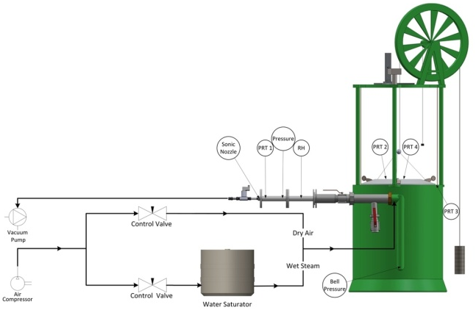
Figure 1. Schematic diagram of the setup used at NMI to measure the effect of relative humidity on the coefficient of critical flow Venturi nozzles.

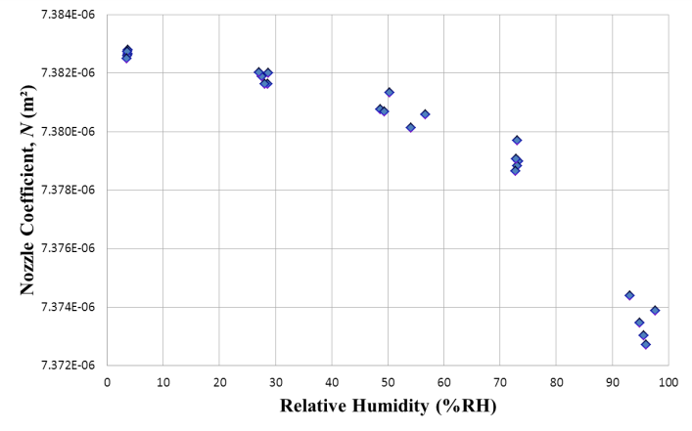
Figure 2. Results for the nozzle coefficient, N, measurements using an NMIA 3.8 mm stainless steel nozzle at different relative humidities.

Normally, dry air is used for nozzle calibration, but for the measurements here, a divided flow humidifier was constructed. This humidifier used needle valves to control the flow of two dry air streams. The wet gas stream was humidified by wet-gas through a large plastic drum filled with water, and the two streams mixed prior to passing into the bell prover. The relative humidity of the gas stream was measured using a calibrated Vaisala HMP233 RH probe placed just upstream of the sonic nozzle. Five descents of the bell were taken for each of the four nozzles and at each of the five humidity levels.

Results and Discussion
The measured nozzle coefficients for a 3.8 mm ID nozzle are presented in Figure 2 up to a relative humidity of 95% (0.025 water vapour mole fraction). For dry-air the repeatability of the measurements is consistent with that observed in previous measurements [9], with typical standard deviation of 0.015%. At higher humidity levels, the variation is slightly larger, which may be attributed to possible instability of the humidity level attained in the bell. A substantial drop of 0.12% in the nozzle coefficient is observed from these results for a change of 95%RH. This change is significant compared to the typical calibration uncertainty (0.13%) assigned to these nozzles. It is very important to note that the effects due to the change in density of the air due to the addition of water vapour are already included in the sonic nozzle equation (1); this effect is due to a change in the “effective area” of the nozzle (i.e. either in $C_{*}$, $C_{d^{'}}$ or $C_{R}$).

To investigate if this effect was related to the boundary layer effects, for example due to the change in viscosity of the air with additional water vapour, measurements were also performed for nozzles with diameters of 1.5, 2.7 and 6.5 mm. For each set value of relative humidity, five measurements were taken and their averages were calculated. Figure 3 shows the results obtained for all nozzles, normalised to the nozzle coefficient for dry air. The error bars reflect the measured standard deviation and the uncorrelated components identified in [9]. No significant correlation with nozzle diameter was observed, suggesting that the decrease in nozzle coefficient is not related to boundary layer effects.

The theoretical values obtained from Aschenbrenner and Briton et al. are also presented: both the theoretical models and our measurement data show a change in nozzle coefficient linear with water-vapour mole fraction.

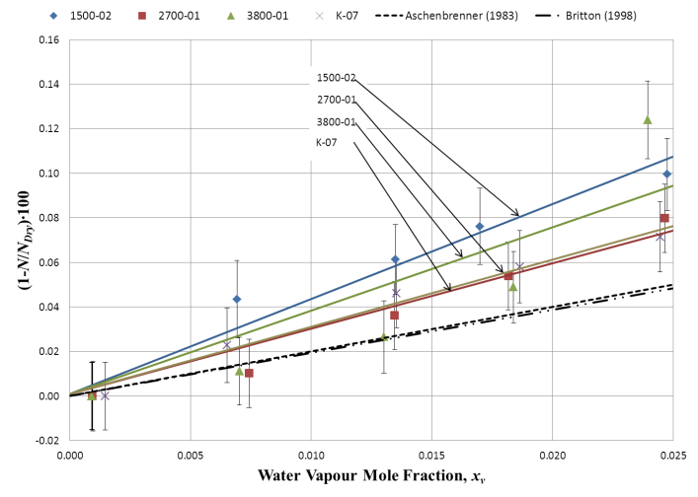
Figure 3. Plots of the relative change in nozzle coefficient, (1-N/N_{Dry})×100, with humidity measured for the sonic nozzles 1500-02 (ID 1.5 mm), 2700-01 (ID 2.7 mm), 3800-01 (ID 3.8 mm) and K07 (ID 6.5 mm). The theoretical values calculated by Aschenbrenner and Britton et al. are also shown.

Conclusion
Methods for measurement of the nozzle discharge coefficient in humid air have been developed and measurements performed on a range of nozzles. The measured nozzle coefficient was found to decrease linearly with water-vapour mole fraction, by between 0.07% and 0.12% for highly humidified air. For the range of nozzles tested, no significant correlation with nozzle diameter was identifiable, suggesting that boundary layer effects are not significant. Although the results were similar to those predicted by theoretical models of several authors, the magnitude of the decrease is slightly larger. NMIA is now considering measurement of the humidity correction factor for individual nozzles where a lower uncertainty is required.

Acknowledgements
The authors would like to thank Mr Zhe Wang for his assistance and efforts in conducting the experimental work presented in this paper.

References

[1] K. Chahine, “Comparison of Low Pressure Gas Flow Standards”, in the 13th International Flow Measurement Conference 2005, Peebles, Scotland: NEL, 2005.

[2] A. Picard et al., “Revised formula for the density of moist air (CIPM-2007)”, Metrologia, 2008, 45(2), pp. 149−155.

[3] ISO9300, Measurement of Gas Flow by Means of Critical Flow Venturi Nozzles. 2nd edition ed. 2005: International Organisation for Standardisation.

[4] A. Melling et al., “Interpolation correlations for fluid properties of humid air in the temperature range 100 degrees C to 200 degrees C”, Journal of Physical and Chemical Reference Data, 1997, 26(4), pp. 1111−1123.

[5] A. Aschenbrenner, “The influence of humidity on the flowrate of air through critical flow nozzles”, in Flomeko 1983, Budapest, Hungary, pp. 71−74.

[6] C.L. Britton, R.W. Caron and T. Kegel, “The Critical Flow Function, C*, for humid Air”, in 1998 ASME Fluids Engineering Division Summer Meeting, ASME, Editor, 1998.

[7] N. Bignell, “Using small sonic nozzles as secondary flow standards”, Flow Measurement and Instrumentation, 2000, 11(4), pp. 329−337.

[8] C. Li, C. Wang and L. Cui, “The Experimental Research of Humidity on Discharge Coefficient of Sonic Nozzles”, in 7th ISFFM, CEESI, Colorado, USA, 2009.

[9] K. Chahine and M. Ballico, “Assessment of Reproducibility and Linearity of the NMIA Bell Prover using a High Flowrate Sonic Nozzle Array”, in the 15th International Flow Measurement Conference 2010, Taipei, Taiwan: IMEKO, 2010.

