MSM22 abstract template – put here the title of your presentation
John Author¹, Lucy SecondAuthor^{2,3}
¹First affiliation
john.author@correspondence.email.com
²Second affiliation
³Third affiliation

This is an abstract template for MSM22 conference (August 28 – September 2, 2022, Duisburg, Germany). Please keep your abstract length at one page including Figures, Tables, References, Acknowledgement section, etc. The abstract should be written in English and can include figures and other objects as long as they fit in the single page limit. Do not vary the margins and do not modify the settings of this template (line spacing, font size, etc.).
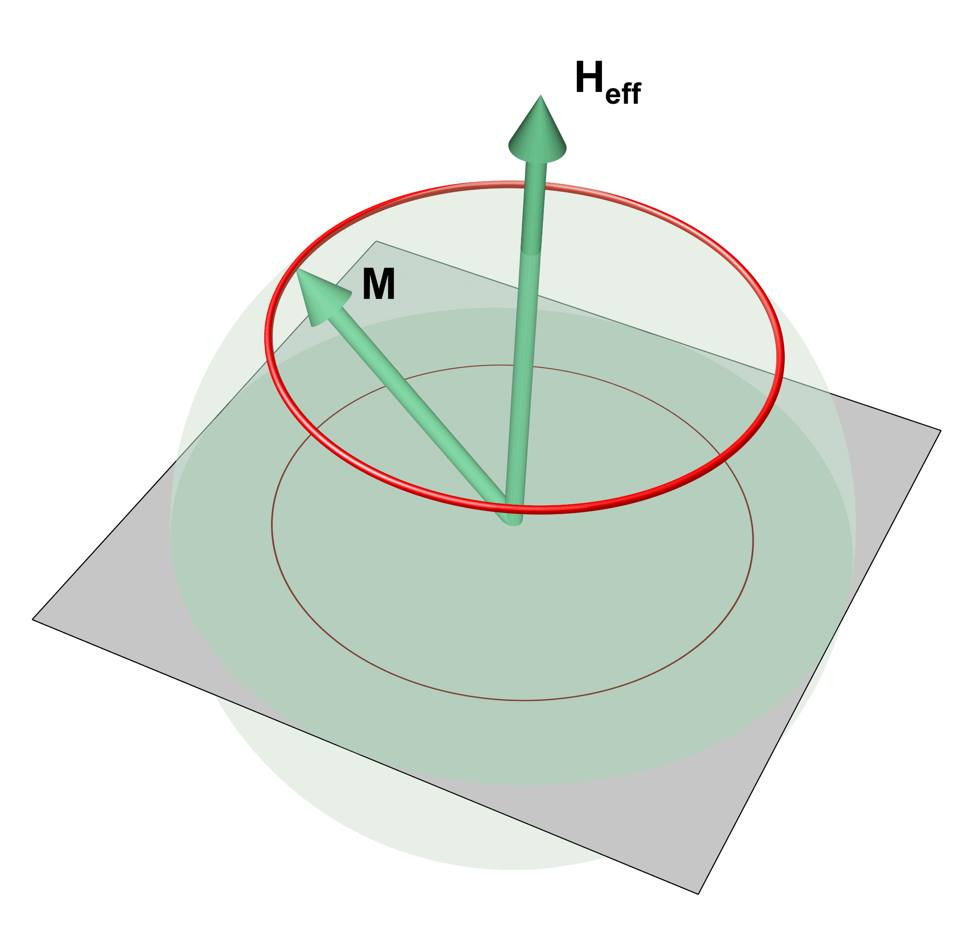
Figure 1. Example of figure and figure capture embedded in the main abstract text. Do not forget to cite figure in the text of your abstract.
Figure capture shall be placed below the figure (Fig. 1). We recommend to position figures and captures using tables with transparent borders as suggested within this template.
Acknowledgement to funding can be added after the main text of abstract. If references are used, they shall be numbered sequentially [1]. Suggested style for references is given in the end of the template [2].
Tables should have a clear structure, with simple column headings that include all units in parentheses.
Abstract shall be submitted as a single MS Word file (doc/docx/rtf) using MSM22 website https://www.uni-due.de/msm22/registration.php. Abstracts sent via email will not be processed or acknowledged. Deadline for abstract submission is April 25 June 6, 2022. Notification about acceptance of submitted contributions will be sent latest on June 17, 2022.
The size of abstract shall not exceed 10 Mb.

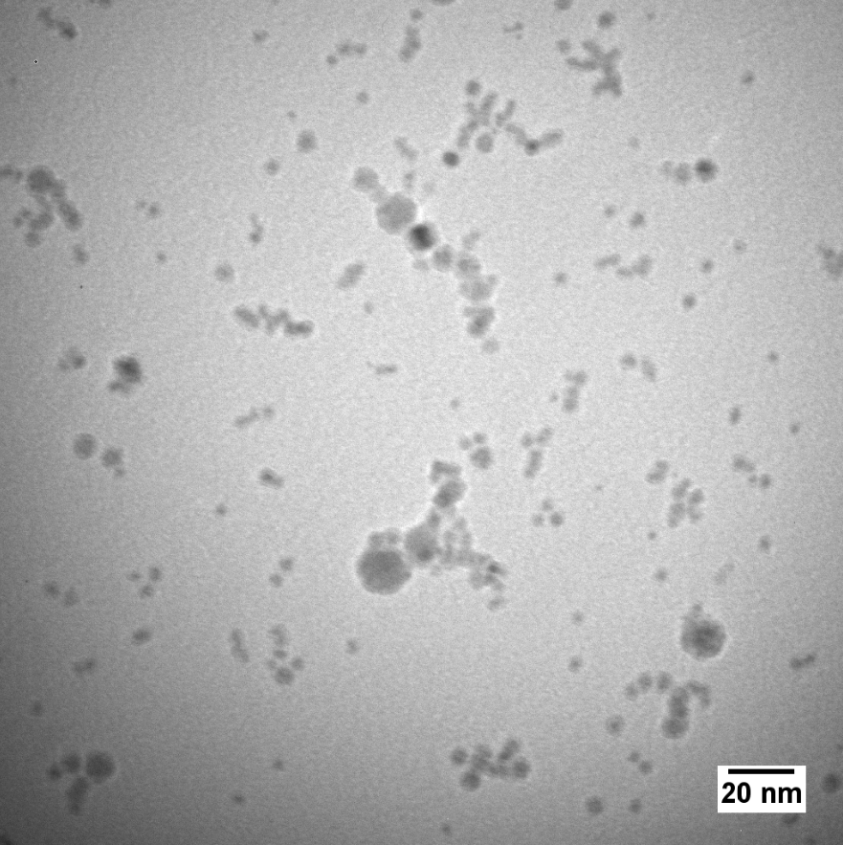
Figure 2. Example of figure and figure capture following the main abstract text. Do not forget to cite figure in the text of your abstract.

The financial funding from DFG (Project AA 1111/5-1) and IEEE is gratefully acknowledged.

[1] A.S. Clark et al., Materials Research Letters 12, 32 (2017).
[2] B. Liu et al., PRB 12, 247678 (2021).
[3] I.T. Prius et al., Sci. Rep. 3, 222 (2020).

