Our excursion to Liverpool

I really enjoyed the trip to Liverpool, it was awesome! I don’t know how to start, since we have done so many amazing things. But let’s begin with the first impressions of the city. When we arrived at the bus station the first thing I realized was, that Liverpool is a really busy and vibrant city. On our way to the meeting point we saw a lot of large buildings. This leads me to the first topic, namely the splendid architecture of Liverpool. I particularly enjoyed the trip to Liverpool Cathedral. The cathedral was huge and its ornaments were very detailed and beautiful. But its interior was even better, especially the stained-glass windows. The town hall and the Victorian buildings in the city center were very impressive, too.
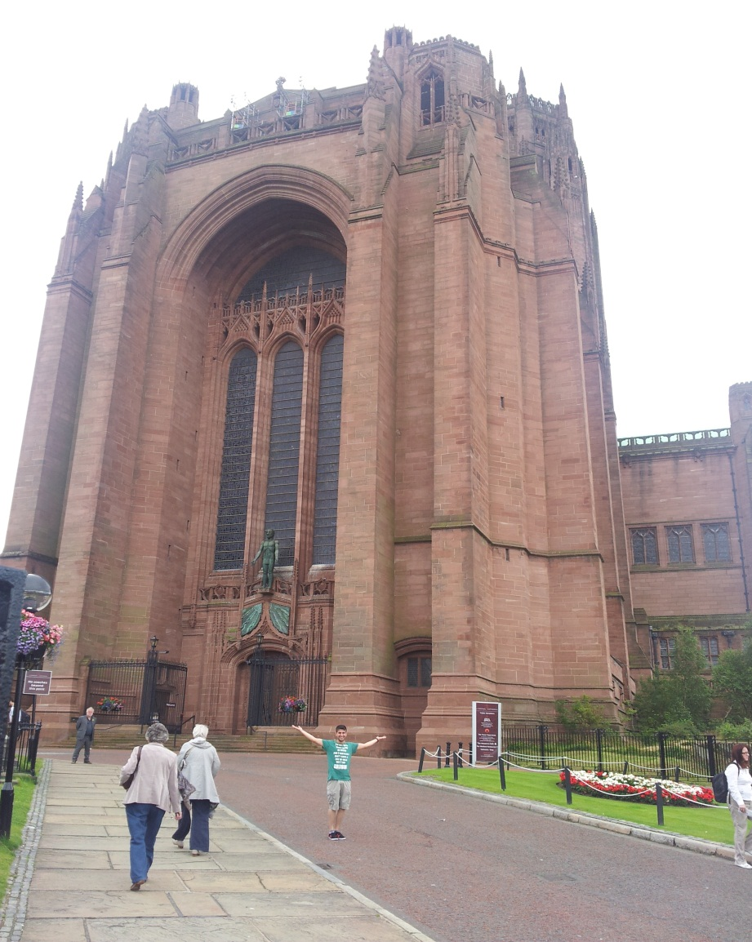
Now I’ll deal with the second topic, the pub culture and night life of Liverpool. We visited a lot of pubs during our stay and most of them had a chilling atmosphere and tasty beer. There was a great diversity of guests in these pubs, for example there was one pub with guests who were around eighty years old or older and other guests who were eighteen years old or even younger. All guests were enjoying their selves and drinking their beer and listening to music which was even played live in one of the pubs, the so-called “Cavern Club”. The night life was also amazing. We visited a variety of clubs which were all fantastic, except one club where we accidently dropped in and which had its décor in pink.
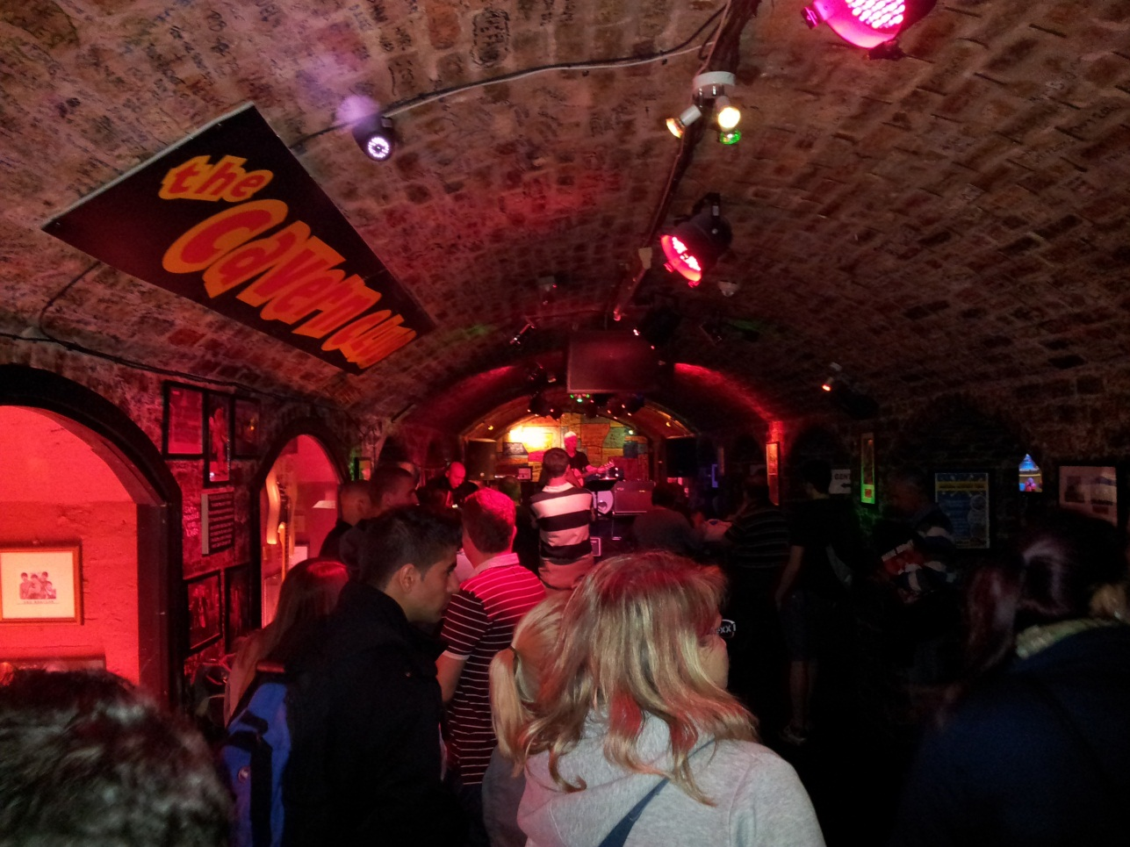
The next topic is the Beatles hype in Liverpool. Most impressive was the Beatles homes’ tour. We learned where and how the Beatles used to live when they were young. The guides were really passionate and told us a lot about the early years of the Beatles. We were driving on Penny Lane while listening to the song with the same name. The whole town was in some kind of never-ending Beatles fever, there where Beatles’ roads, buildings and pubs which all claimed to be the one and only Beatle’s pub.
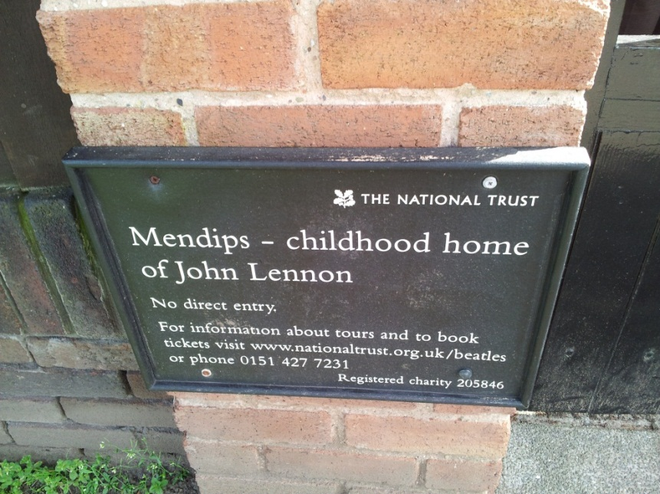
Another highlight of the trip was the Indian meal. It was really delicious and you could try a lot of different meals, some of them were spicy, others were sweet.
Equally good was the trip to the Liverpool FC stadium. We could see the players’ dressing room, the pitch, the seats and last but not least the conference room. The stadium is a must-see for every football fan.
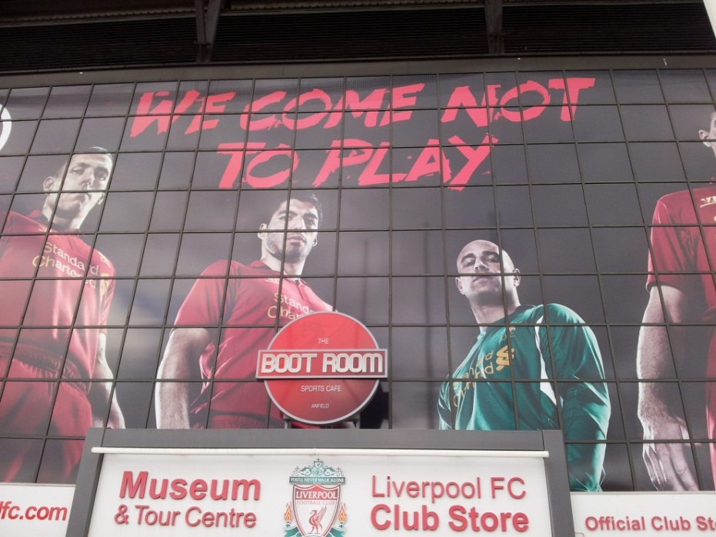
In summary, the trip to Liverpool was awesome. We met a lot of nice people, visited amazing sights and did many exciting activities. I recommend every student of English to participate in next year’s excursion, especially because of the nice and well prepared excursion leader.
Cheers!
Jan

