Liverpool-Excursion
Lots of people all over the world think that London is the face of England. But this is not the case! In our opinion as fully-integrated Liverpudlians, Liverpool, the port city upon the Merseyside in the north-west of England, is definitely the heart of Britain. It has many facets of ravishing beauty and fabulous wealth. Our trip was filled with interesting cultural places and tourist attractions as The Walker Art Gallery, the Albert Dock, The Speke Hall or the Liverpool Town Hall. This is the reason why in 2008 Liverpool was celebrated with the city holding the title of European Capital of Culture or is generally labeled as the World Capital City of Pop. Because of the fact that Liverpool was the birthplace of the Beatles, we visited the homes of John Lennon and Paul Mc Cartney, which was my personal highlight. We additionally went to lots of pubs, where the Beatles originated their music as in the Cavern Club, a very nice atmosphere with life music and nice beer: Cracker! (Scouse English: Great!)
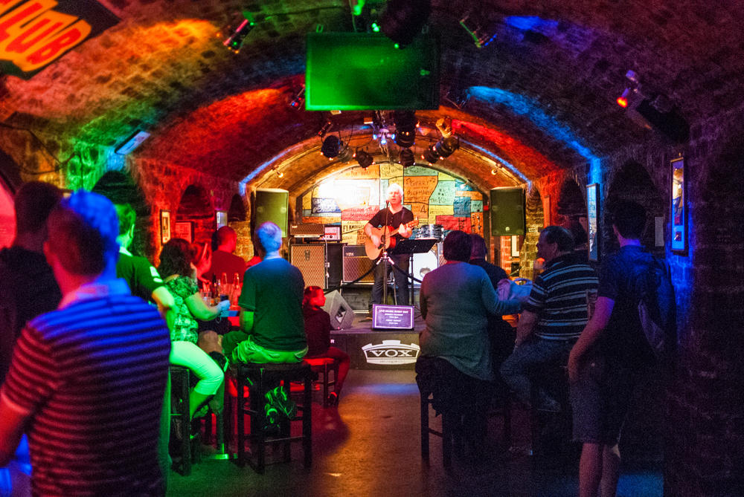

It was a gregarious evening. And let us be honest, beer belongs to the culture of the Scousers. So we took part of a spontaneous demonstration as you can see below, and sorry for the monochrome pic but what a wonderful one ;) These buggeroos! (Scouse English:These naughty boys!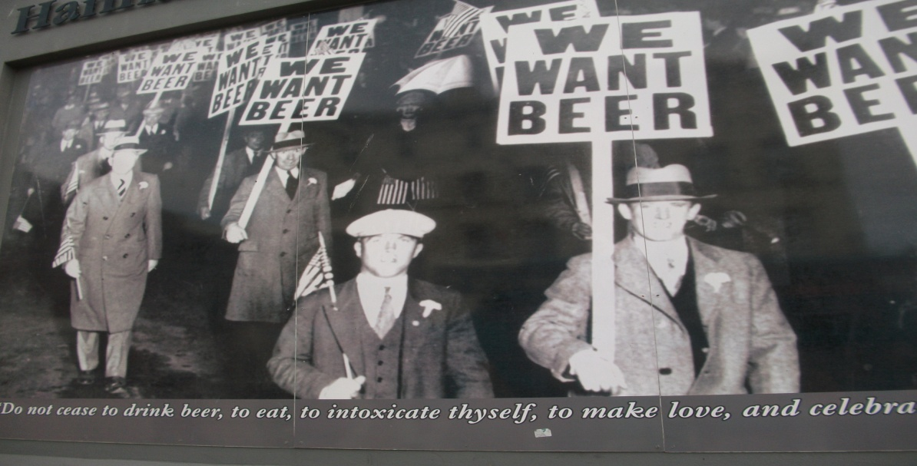
Our group consisted of witty-mood people, tried to speak with lots of Liverpoolers as much as possible with the purpose to practice our Englishes. It was very interesting to all of us to hear the local dialect of Scouse-English. Lots of people were very friendly and polite. Indeed, they loved to discuss with us. Even the birds had no fear enjoying us: Ullo wack? (Scouse English: How are you mate?)
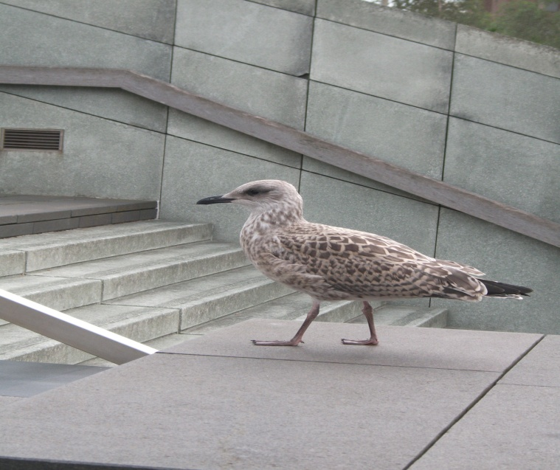

Liverpool is noted for its rich architectural heritage and is home to many buildings regarded as amongst the greatest examples of their respective styles in the world. The first pic shows the Liverpool’s Three Graces of Victorian architecture: The Royal Liver Building with the two Liver birds on it, the Cunard Building and the Port of Liverpool Building. Very beautiful! The second one depicts the combination of old and modern architecture. Ace! (Scouse English: Well done)

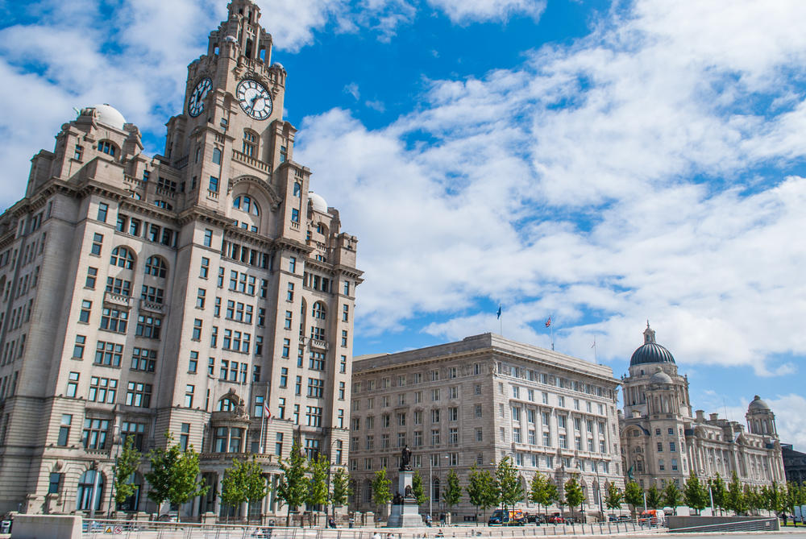

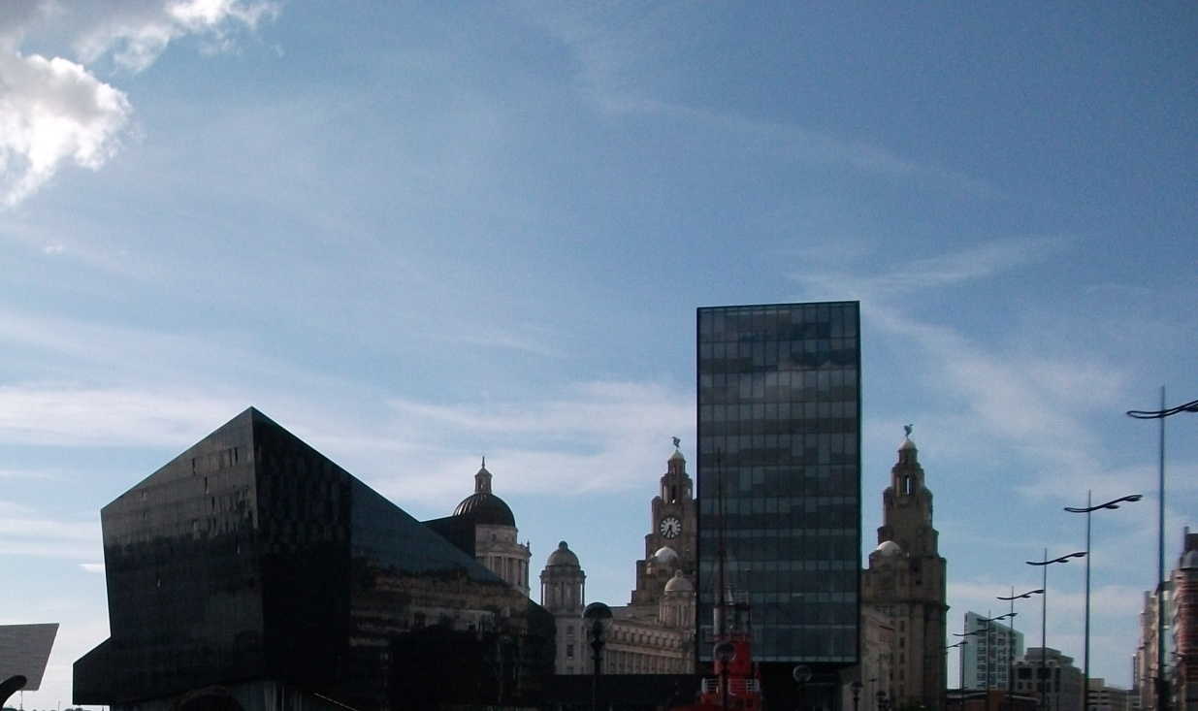

Liverpool is also well known for its strong sporting identity. More precisely, the city is home of two Premier League Togga (Scouse English: Football) clubs, the Reds (FC Liverpool) and the Blues (FC Everton), which have a big rivalry between them. Matches between the two clubs are known as the Merseyside derby. Here you can see the group with our excursion leader Mr. Deane at the Anfield Stadium before the statue of Bill Shankly, a legend and former team manager of Liverpool.
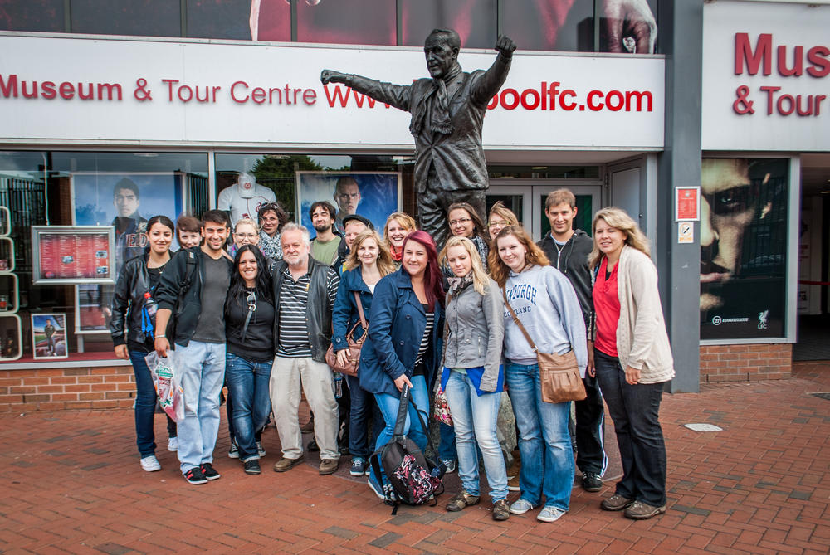

Unfortunately, The Reds did not start successfully into the current season. Hopefully, the following picture gives them enough energy and power to be at the top of the League at the end of the season. A propos, we send the best and hearty regards to Mr. Deane’s’ Dad, who is the greatest fan of Liverpool.

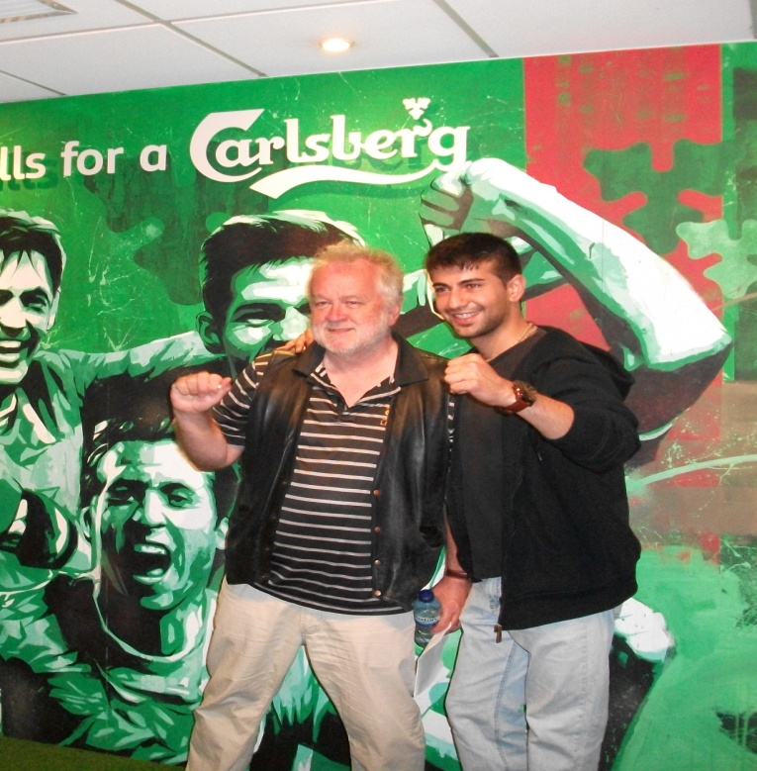

Another highlight was the tour by ferry across the Mersey. We had quite luck with the weather, especially considering that it was raining moments ago before the ferry started, but Fortune smiled upon us, so that we finally got amazing sights onto Liverpool: boss! (Scouse English: marvellous)

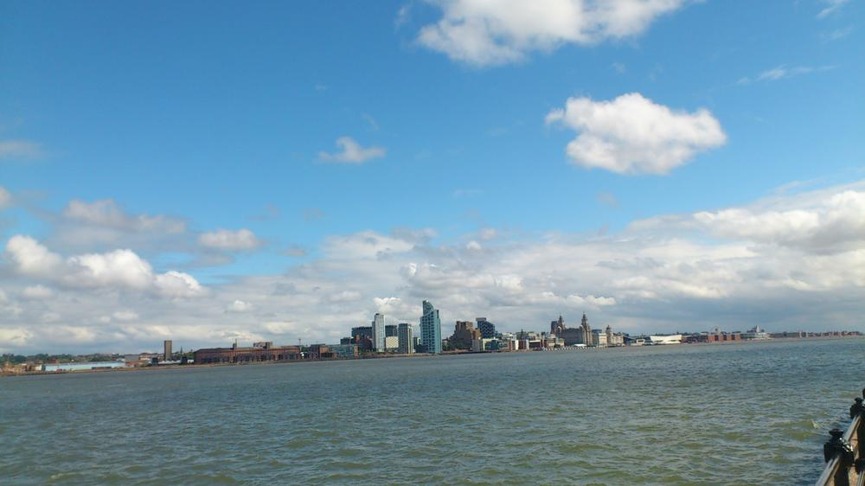
Liverpool is really the pool of life! We totally enjoyed our trip and recommend the city to all, who are ready for any venture. Zarrafact?(ScouseEnglish: You don’t believe me)Well, lemme put it in these words: Shtum (Shut up) you Woollyback (Someoe who isn’t a Scouser) and find out for yourself! The last pic below was taken in front of the Speke Hall Building, one of Liverpool’s oldest Tudor buildings. Ta (Thanks) to Mr. Deane and have fun next year with a new group.
