Towards high-resolution LES simulations of wildfires: Benchmarks using a generic miniature tree
To further develop physics-based forest fire models, generic pinewood model trees are being studied both experimentally and numerically under controlled conditions. The precise design of the model trees, together with a standardised ignition procedure under dry conditions, allows for reproducible experiments. The numerical simulation is based on the coupling of thermally thick mesh-based solid particle models with a steady flamelet approach for the gas phase.
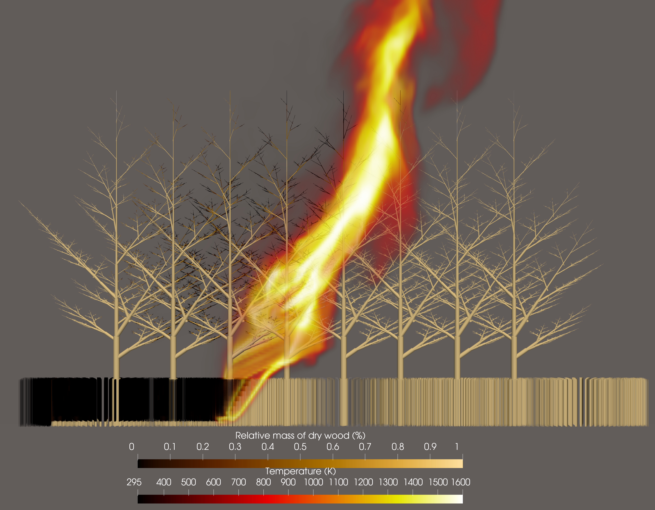
Figure 1: A simulated fire spreads across grass and trees; the trees are ~5.3 metres tall; the ground fire spread to the treetops and set the smaller branches alight.
When using Lagrangian particles or the discrete element method to simulate solid biomass particles, an important factor is how these particles are coupled with the Eulerian gas phase. Using the classical particle-centroid method, if particles occupy more than 3% of a gas cell's volume, significant numerical errors and grid dependencies arise. Modern grid-independent methods enable the representation of particles between fully resolved ($d_{p}>10Δ$) and unresolved ($d_{p}<<Δ$) states. Our in-house LES solver, PsiPhi, has been enhanced with a grid-independent diffusion methodology utilising modern MPI RMA (one-way communication). The weights for coupling spherical particles with the gas phase now depend on integrated diffusion, the Gaussian function, and the particle diameter — together forming the Gaussian kernel.
The biomass present in the forest, such as branches, twigs and blades of grass, is represented by cylinders. These cylinders can vary greatly in diameter and length, reflecting the many different physical scales of forest fires. Grid-independent interaction is therefore extremely important. The Gaussian kernel was adapted to suit the cylinders and applied to the generic miniature tree. Figure 1 (left) shows the charcoal remaining after the pyrolysis of the generic miniature tree's biomass. The figure on the right shows the mass loss rate for cylinders of different lengths (slicing), using a constant Eulerian grid. The different cylinder lengths demonstrate a consistent trend. This ensures grid independence.
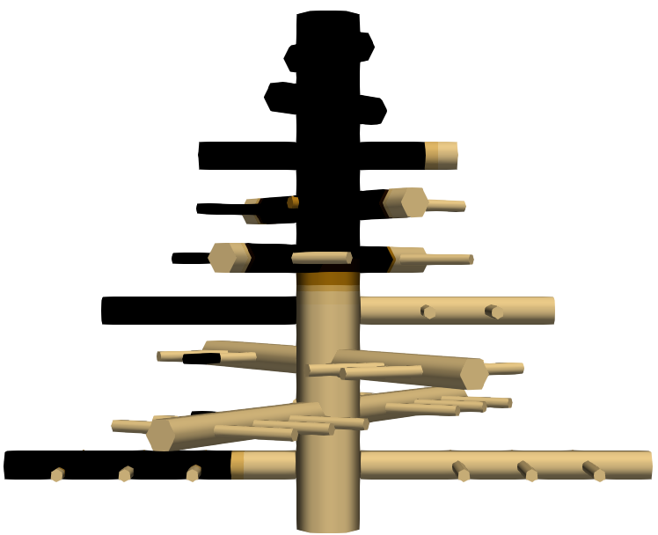 | 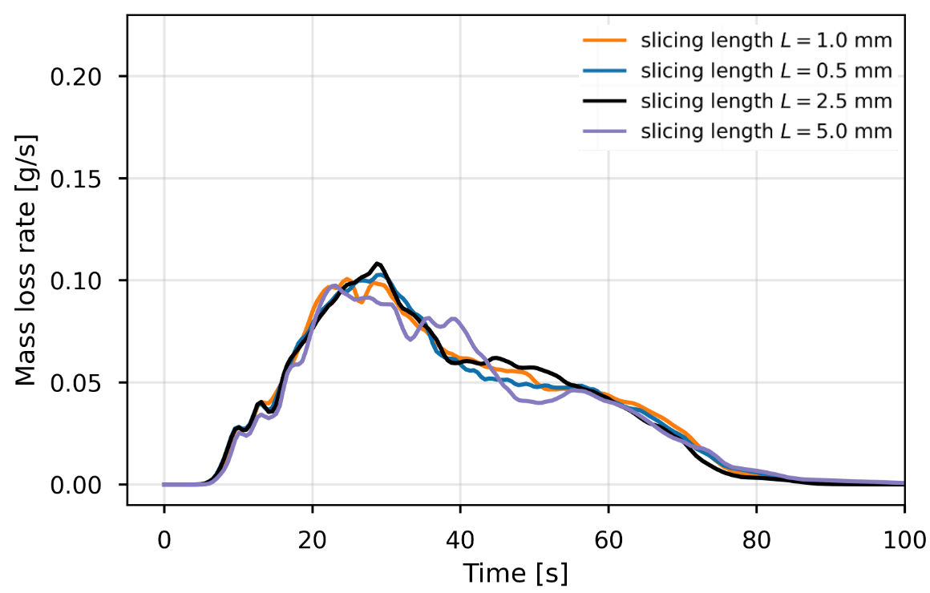
Figure 2: Left: charring of the generic miniature tree; Right: mass loss rate for different cylinder lengths
When this is applied to a LES simulation of a wildfire, the influence of multi-scale particle sizes is significantly reduced. This brings us closer to achieving an accurate wildfire simulation.

